Chapter 19, Solution 92

Due to the resistor 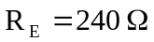, we cannot use the formulas in section 18.9.1. We will need to derive our own. Consider the circuit in Fig. (a).

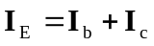 (1)
h_{oe}
h_{fe} I_{b}
h_{ie}
+
−
h_{re} V_{c}
Z_{in}
I_{E}
+
−
I_{b}
I_{c}
+
V_{c}
−
V_{s}
R_{s}
R_{E}
R_{L}
+
V_{b}
−
(a)

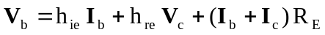 (2)

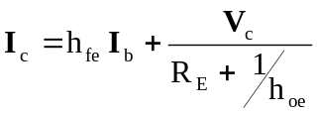 (3)
But 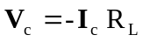 (4)

Substituting (4) into (3),
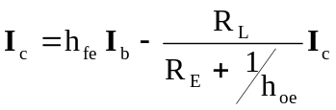

or 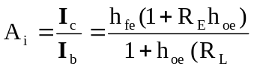 (5)

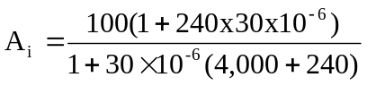
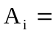79.18

From (3) and (5),
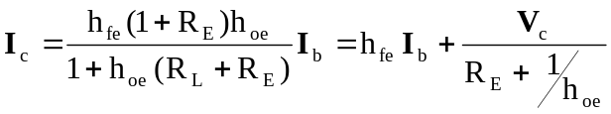 (6)

Substituting (4) and (6) into (2),
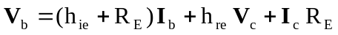
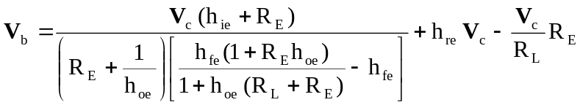

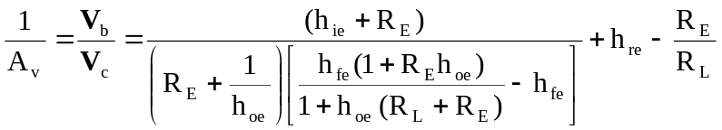 (7)

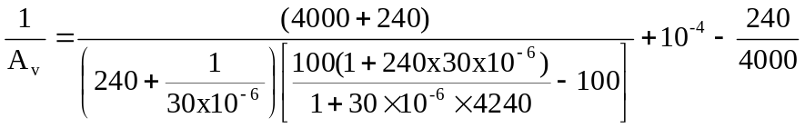
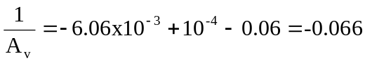

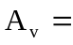 –15.15

From (5),
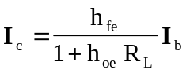

We substitute this with (4) into (2) to get
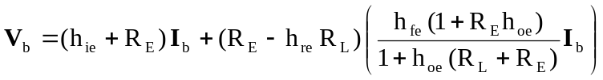

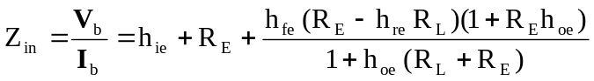 (8)

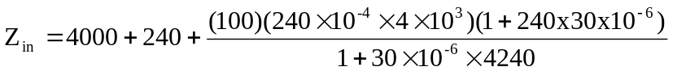
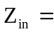 12.818 kΩ

To obtain 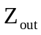, which is the same as the Thevenin impedance at the output, we introduce a 1-V source as shown in Fig. (b).
h_{oe}
h_{fe} I_{b}
h_{ie}
+
−
h_{re} V_{c}
Z_{out}
I_{E}
+
−
I_{b}
I_{c}
+
V_{c}
−
R_{s}
R_{E}
1 V
+
V_{b}
−
(b)

From the input loop,

But 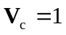

So,
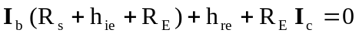 (9)

From the output loop,
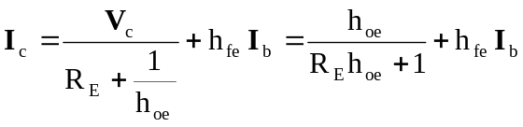

or 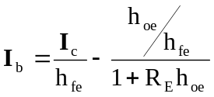 (10)

Substituting (10) into (9) gives
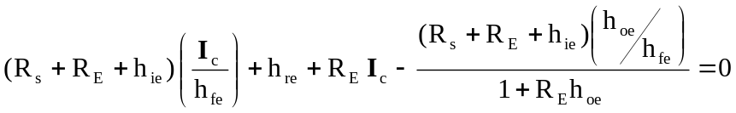
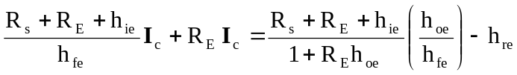

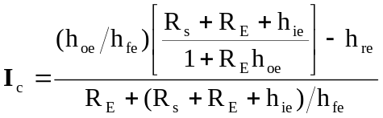

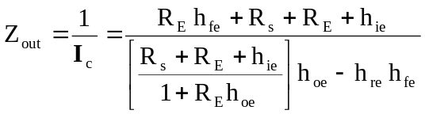

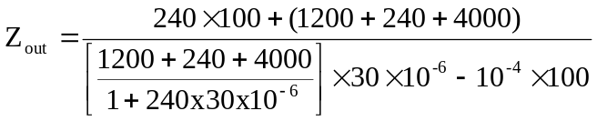
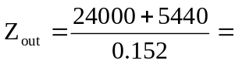 193.7 kΩ

